1. festival n. 节日Spring Festival traditional festival dragon boat festival lantern festival

2 lantern ['læntən] n.灯笼

3 spectacle ['spektəkəl] n.景象，壮观，场面

# Lesson 96 单词讲解

本课重点:

复习分析长难句

# Lesson 96 课文&语法讲解

A Festival for the Dead is held once a year in Japan.

the + adj. 表示一类

thedead theliving the rich the poor

1. … for on this day, the dead are said to return to their homes and they are

welcomed by the living.

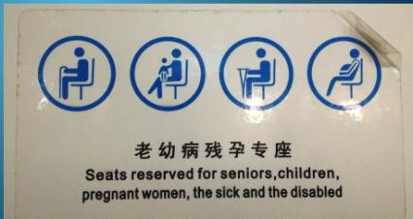

be said to do sth. “据说”

be welcomed by … 被动语态

2.As they are expected to be hungry after their long journey, food is laid out for them.

lay laid laid

v. 放置，摆放／产卵，下蛋

lay out food

1. Specially-made lanterns are hung outside each house to help the dead to find their way.

specially-made adv. + done = adj. well-dressed

well-ventilated

newly-arrived

1. In the early morning, the food that had been laid out for the dead is thrown into a river or into the sea as it is considered unlucky for anyone living to eat it.
2. In towns that are near the sea, the tiny lanterns which had been hung in the streets the night before, are placed into the water when the festival is over.

In towns…, the tiny lanterns…, are placed into the water…

1. Thousands of lanterns slowly drift out to sea guiding the dead on their return journey to the other world.
2. This is a moving spectacle, for crowds of people stand on the shore watching the lanterns drifting away until they can be seen no more.

# Lesson 96 知识拓展

恭喜大家，

我们胜利地收官啦！！！

感谢大家的陪伴和支持！！！

英语的基础：词汇 + 语法

英语的应用：听 说 读 写 译

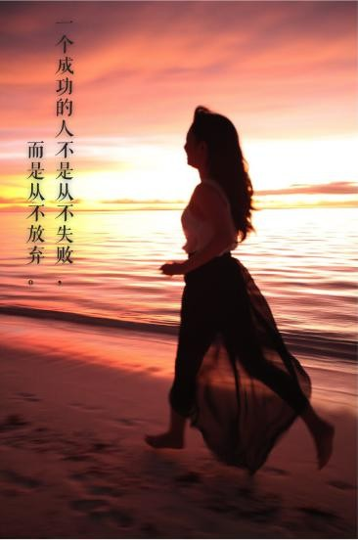

一个成功的人， 不是从不失败，

而是从不放弃。